Experiment 1_b_C
- Introduction to analysis of algorithm : Divide and Conquer Approach
  - Demonstrate time complexity
  - Selection sort , insertion sort.
  - Merge sort, Quick sort, Binary search.
b and c)Theory:

Selection sort: Selection sort is a simple sorting algorithm. This sorting algorithm is an in-place comparison-based algorithm in which the list is divided into two parts, the sorted part at the left end and the unsorted part at the right end. Initially, the sorted part is empty and the unsorted part is the entire list.
The smallest element is selected from the unsorted array and swapped with the leftmost element, and that element becomes a part of the sorted array. This process continues moving unsorted array boundary by one element to the right.
This algorithm is not suitable for large data sets as its average and worst case complexities are of Ο(n²), where n is the number of items.
Sort: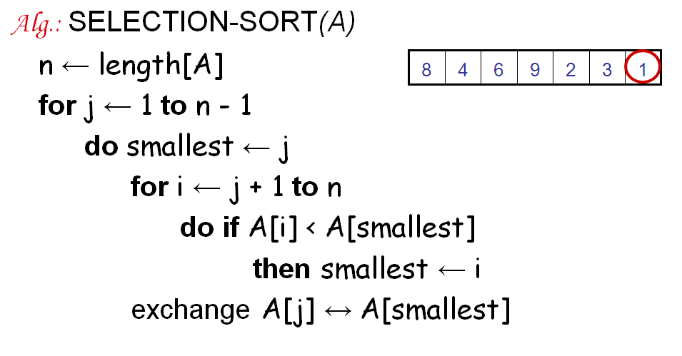
Insertion Sort:

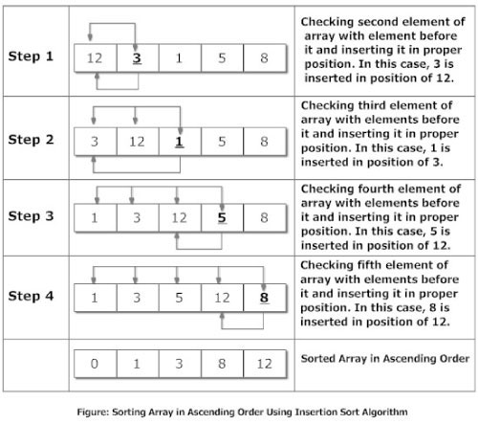
Explanation
Suppose, you want to sort elements in ascending as in above figure. Then,
- Step 1: The second element of an array is compared with the elements that appears before it (only first element in this case). If the second element is smaller than first element, second element is inserted in the position of first element. After first step, first two elements of an array will be sorted.
- Step 2: The third element of an array is compared with the elements that appears before it (first and second element). If third element is smaller than first element, it is inserted in the position of first element. If third element is larger than first element but, smaller than second element, it is inserted in the position of second element. If third element is larger than both the elements, it is kept in the position as it is. After second step, first three elements of an array will be sorted.
- Step 3: Similary, the fourth element of an array is compared with the elements that appears before it (first, second and third element) and the same procedure is applied and that element is inserted in the proper position. After third step, first four elements of an array will be sorted.
If there are n elements to be sorted. Then, this procedure is repeated n-1 times to get sorted list of array.

Merge sort : algorithms are based on a divide and conquer strategy. First, the sequence tobe sorted is decomposed into two halves (Divide). Each half is sorted independently Conquer).Then the two sorted halves are merged to a sorted sequence (Combine).Its worst-case running time has a lower order of growth than insertion sort. Since we are dealing with subproblems, we state each subproblem as sorting a subarrayA[p .. r]. Initially, p = 1
andr = n, but these values change as we recurse through subproblems.
To sort A[p .. r]:
1. Divide Step
If a given array A has zero or one element, simply return; it is already sorted.
Otherwise, split A[p .. r] into two subarraysA[p.. q] and A[q + 1 .. r], each
containing about half of the elements of A[p .. r]. That is, q is the halfway point
ofA[p .. r].
2. Conquer Step
Conquer by recursively sorting the two subarraysA[p .. q] and A[q + 1 .. r].
3. Combine Step
Combine the elements back in A[p .. r] by merging the two sorted subarraysA[p .. q]
andA[q + 1 .. r] into a sorted sequence
Algorithm MergeSort( int A[0....n-1,low,high) :
if (low<high) then
{
mid ← (low+high)/2
MergeSort(A,low,mid)
MergeSort(A,low,mid)
Combine(A,low,mid,high)
}
Algorithm Combine(int A[0....n-1,low,high) :
1. k ← low
2. i ← low
3. j ← mid+1
4. while(i<= mid && j<=high) do
{
if(A[i]<=A[j] then
{
temp[k] ← A[i]
i←i+1
k←k+1
}
else
{
temp[k] ← A[j]
j←j+1
k←k+1
}
}
5. while(i<=mid) do
{
temp[k] ← A[i]
i←i+1
k←k+1
}
6. while(j<=high) do
{
temp[k] ← A[j]
j←j+1
k←k+1
}

Quicksort is a very efficient sorting algorithm invented by C.A.R. Hoare.
It has two phases:
• the partition phase and
• the sort phase.
As we will see, most of the work is done in the partition phase - it works out where to divide thework. The sort phase simply sorts the two smaller problems that are generated in the partitionphase.In quicksort, we divide the array of items to be sorted into two partitions and then call thequicksort procedure recursively to sort the two partitions, iewe divide the problem into twosmaller ones and conquer by solving the smaller ones.For the strategy to be effective, the partition phase must ensure that all the items in one part (thelower part) and less than all those in the other (upper) part.To do this, we choose a pivot element and arrange that all the items in the lower part are less thanthe pivot and all those in the upper part greater than it. In the most general case, we don‟t knowanything about the items to be sorted, so that any choice of the pivot element will do - the firstelement is a convenient one.

Algorithm Quicksort( A[0……n-1, low, high) :
if( low<high) then
m ← partition(A[low………high])
Quicksort( A[low……m-1])
Quicksort( A[mid+1……high])
Algorithm Partition(A[low……high]):
pivot ← A[low]
i ← low
j ← high +1
while ( i<=j) do
{
while(A[i]<=pivot)do
i ← i+1
while(A[j]<=pivot)do
j ← j+1
if(i<=j)then
swap(A[i],A[j])
}
swap(A[low],A[j])
return j

Thus, in quick sort choice of pivot affects the nature of partitioning. Best case when the pivot divides array into equal halves: both partitions have same nearly number of elements. Number of levels of partitioning - logN Complexity: (N log N). In Worst case, when the pivot isthe largest/smallest element of the array, one partition is empty and the other has all the elements. Number of levels of partitioning N. Complexity degrades to selection sort - 0(N2).Suitable for large and randomly sorted data.Thus in merge sort no best/worst cases. Log N divisions before a size of 1 isreached. Each step requires 0(N) for merging. Hence 0(N log N). Auxiliary storage as large asthe original is required.

Binary Search:

A binary search algorithm is a technique for finding a particular value in a linear array,by ruling out half of the data at each step, widely but not exclusively used in computer science.A binary search finds the median, makes a comparison to determine whether the desired value comes before or after it, and then searches the remaining half in the same manner. Another explanation would be: Search a sorted array by repeatedly dividing the search interval in half Begin with an interval covering the whole array. If the value of the search key is less than the item in the middle of the interval, narrow the interval to the lower half Otherwise, narrow it to
the upper half.
The method is called is binary search because at each step, we reduce the length of the table to be searched by half and the table is divided into two equal parts. Binary Search can be accomplished in logarithmic time in the worst case, i.e., T(n) = θ(log n). This version of the binary search takes logarithmic time in the best case.

Algorithm: Sort an array a[j] in increasing order.
1. Read „n‟ elements in the array , say „a ‟.
2. Read the element to be searched, say „KEY „.
3. low = 0 , high = n-1
4. while(high>=low) perform following steps.
4. Find the middle element.
mid = (low + high )/ 2
5. if ( KEY= a[mid] )
print („ element found at mid position)
6. if KEY < a[mid] then search for target in a[low] to a[mid-l]
else search for target in a[mid+l] to a[high].
7. if (KEY < a[Mid_position])
high = mid_position - 1;
else
low = mid_position + 1;
8. stop.

Conclusion: Thus studied all sorting searching techniques.

